**DATA SCIENCE**

**PYTHON PROGRAMMING ASSIGNMENT**

1. Write a Python program that checks whether a given number is prime or not. A prime number is a natural number greater than 1 that has no positive divisors other than 1 and itself.

def is_prime(n):

"""Check if a number is prime."""

if n <= 1:

return False

if n <= 3:

return True

if n % 2 == 0 or n % 3 == 0:

return False

i = 5

while i * i <= n:

if n % i == 0 or n % (i + 2) == 0:

return False

i += 6

return True

# Example usage:

number = int(input("Enter a number to check if it is prime: "))

if is_prime(number):

print(f"{number} is a prime number.")

else:

print(f"{number} is not a prime number.")

**OUTPUT:**

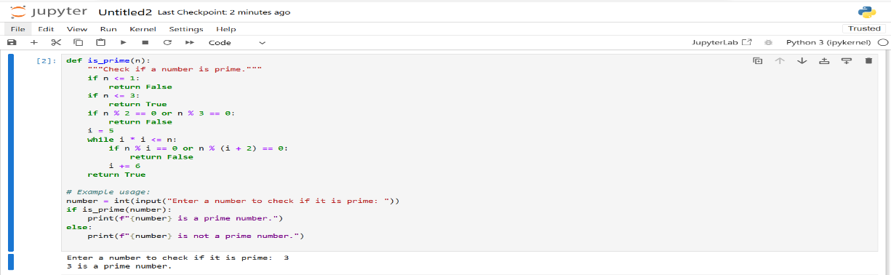

2.Develop a Python program that generates two random numbers and asks the user to enter the product of these numbers. The program should then check if the user's answer is correct and display an appropriate message.

import random

def main():

# Generate two random numbers between 1 and 10

num1 = random.randint(1, 10)

num2 = random.randint(1, 10)

# Calculate the correct product

correct_product = num1 * num2

# Ask the user to enter the product of the two numbers

print(f"What is the product of {num1} and {num2}?")

user_answer = int(input("Enter your answer: "))

# Check if the user's answer is correct

if user_answer == correct_product:

print("Correct! Well done.")

else:

print(f"Sorry, that's incorrect. The correct answer is {correct_product}.")

# Run the main function

if __name__ == "__main__":

main()

**OUTPUT:**

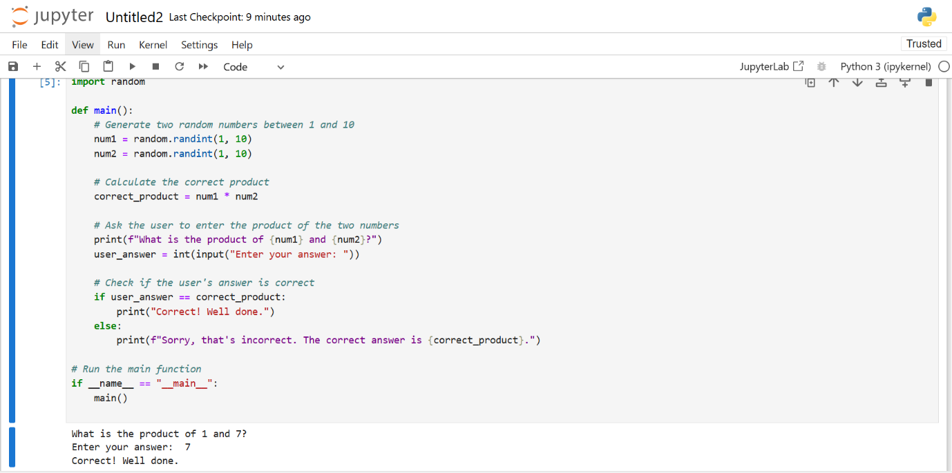

3. Create a Python script that prints the squares of all even or odd numbers within the range of 100 to 200. Choose either even or odd numbers and document your choice in the code.

# Python script to print the squares of all even numbers in the range 100 to 200

def main():

# Define the range

start = 100

end = 200

# Choose to work with even numbers

print("Squares of even numbers from 100 to 200:")

# Iterate through the range and find even numbers

for num in range(start, end + 1):

if num % 2 == 0: # Check if the number is even

square = num ** 2

print(f"The square of {num} is {square}")

# Run the main function

if __name__ == "__main__":

main()

**OUTPUT:**

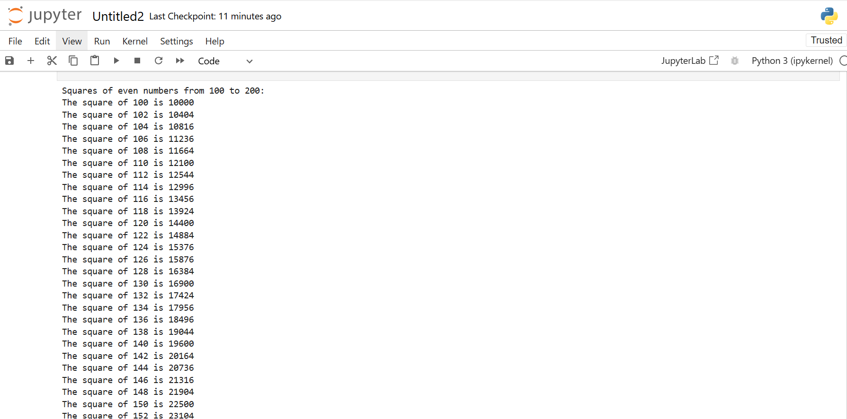

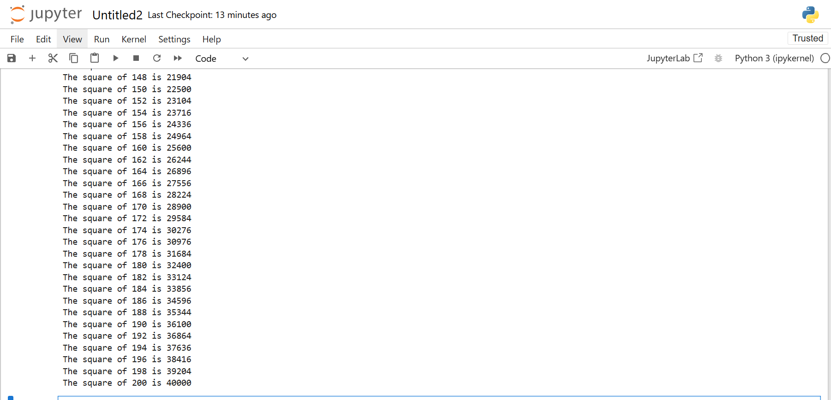

4.write a program to count the number of words in a given text.

example:

input_text = "This is a sample text. This text will be used to demonstrate the word counter."

Expected output:

'This': 2

'is': 1

'a': 1

'sample': 1

'text.': 1

from collections import Counter

import re

def count_words(text):

# Convert text to lowercase and split into words

words = re.findall(r'\b\w+\b', text.lower())

# Count the frequency of each word

word_count = Counter(words)

return word_count

def main():

# Example input text

input_text = "This is a sample text. This text will be used to demonstrate the word counter."

# Count words in the input text

word_count = count_words(input_text)

# Print the results

for word, count in word_count.items():

print(f"'{word}': {count}")

# Run the main function

if __name__ == "__main__":

main()

**OUTPUT:**

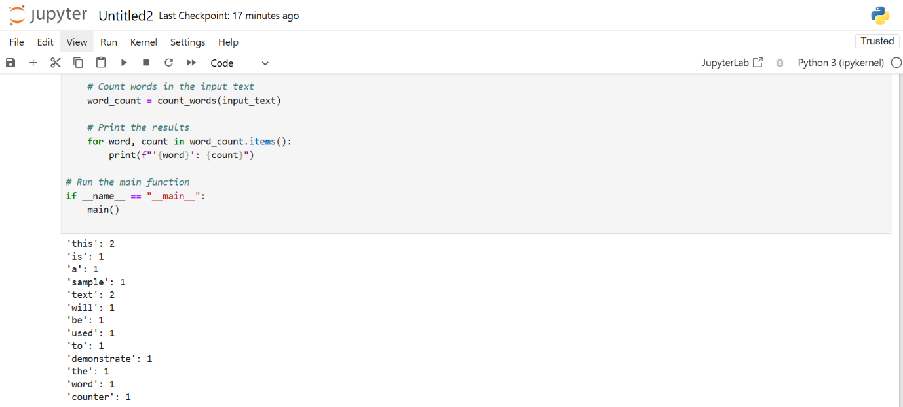

5. Write a Python function called is_palindrome that takes a string as input and returns True if the string is a palindrome, and False otherwise. A palindrome is a word, phrase, number, or other sequence of characters that reads the same forward and backward, ignoring spaces, punctuation, and capitalization**.**

import re

def is_palindrome(s):

"""

Check if a given string is a palindrome.

A palindrome reads the same forward and backward, ignoring spaces, punctuation, and capitalization.

"""

# Normalize the string

normalized_str = re.sub(r'[^a-zA-Z0-9]', '', s).lower()

# Check if the normalized string is equal to its reverse

return normalized_str == normalized_str[::-1]

# Example usage

if __name__ == "__main__":

test_strings = [

"A man, a plan, a canal, Panama!",

"No 'x' in Nixon",

"Hello, World!",

"Madam In Eden, I'm Adam"

]

for text in test_strings:

result = is_palindrome(text)

print(f"'{text}' is a palindrome: {result}")

**OUTPUT:**